**Intro to Amazon Machine Learning**

Time spent: 55min

**What is Amazon ML**

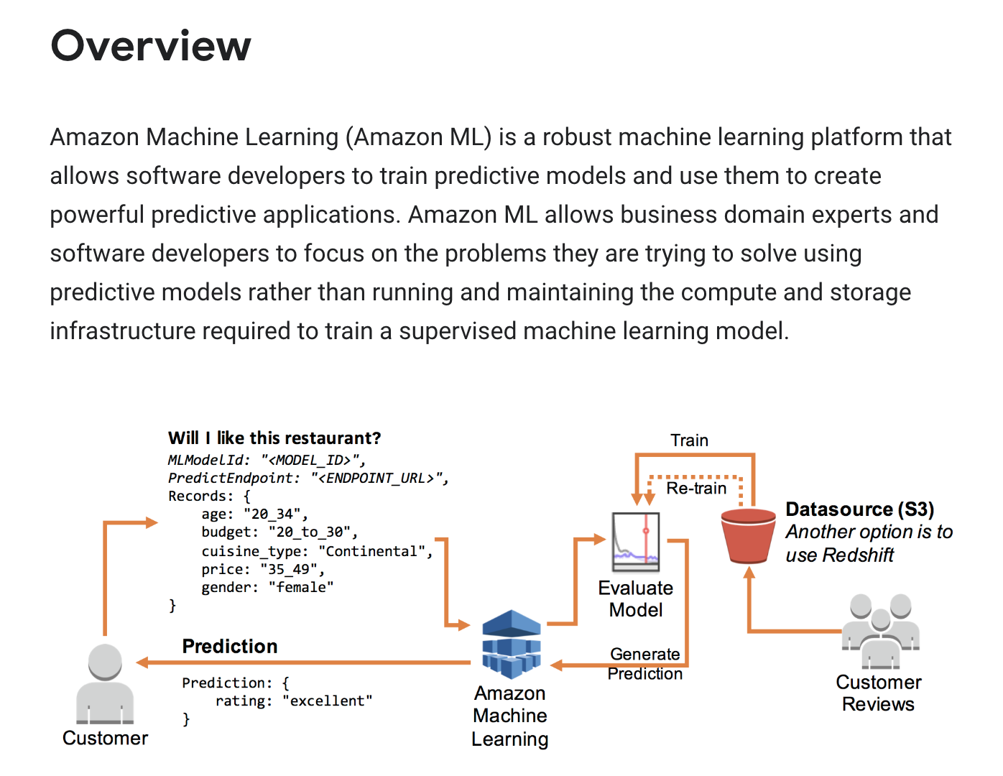

**What I learned**

* **The Amazon ML mechanism**
* **How to use ML model on Amazon ML**
* **How to do the real-time prediction**

**What I built**

* **Use Amazon ML to finish prediction by using restaurants data**

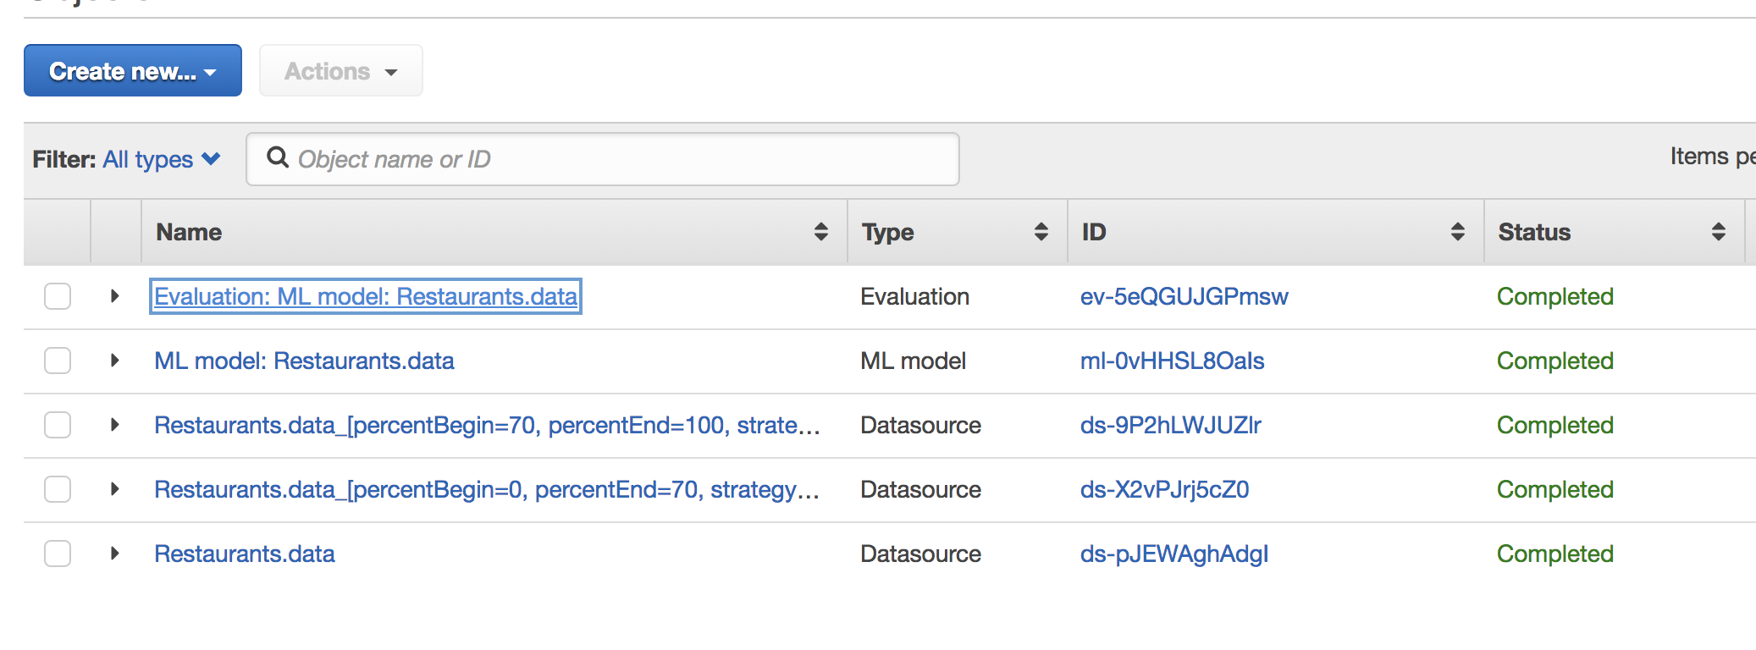

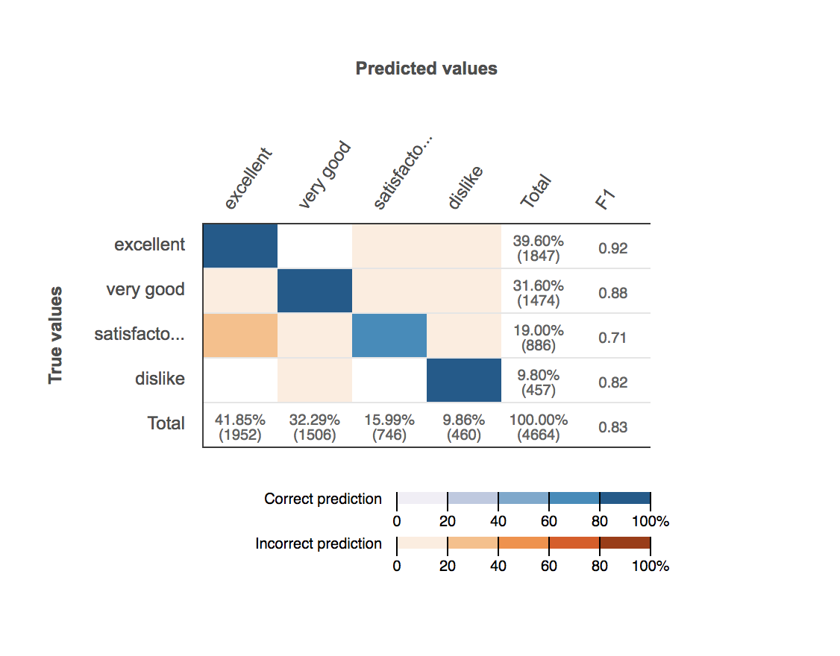

* **Finish the real time prediction by this model**

